1. Pre-requisite:

* The application should be up and running.
* If java17 is present
* Then, right-click on the particular folder and select Git Bash.

Command: Java -jar APITesting-1.0-SNAPSHOT.jar

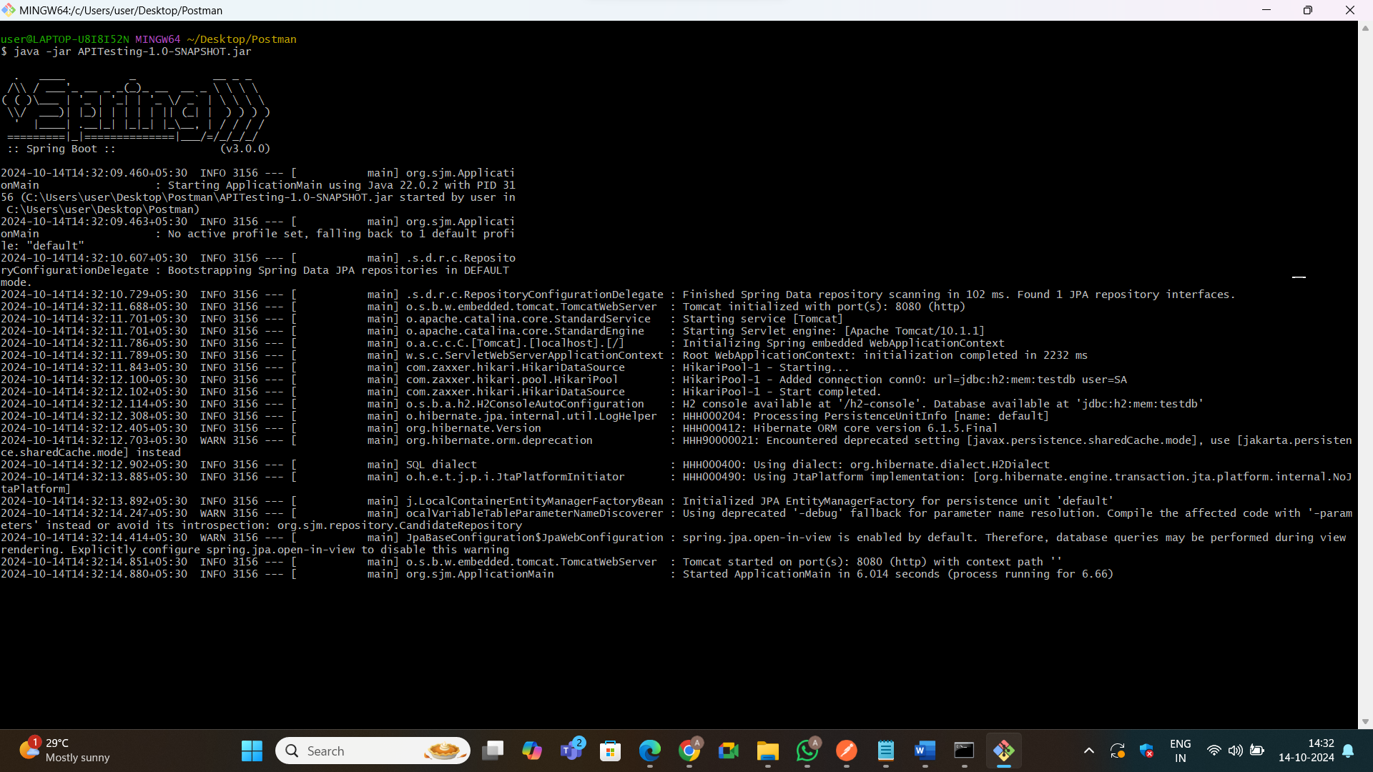

* Then we have to open Postman API.

1. **GET**

Get candidate details.

URL: <http://localhost:8080/api/candidates>

Get is used to retrieve the data from the server

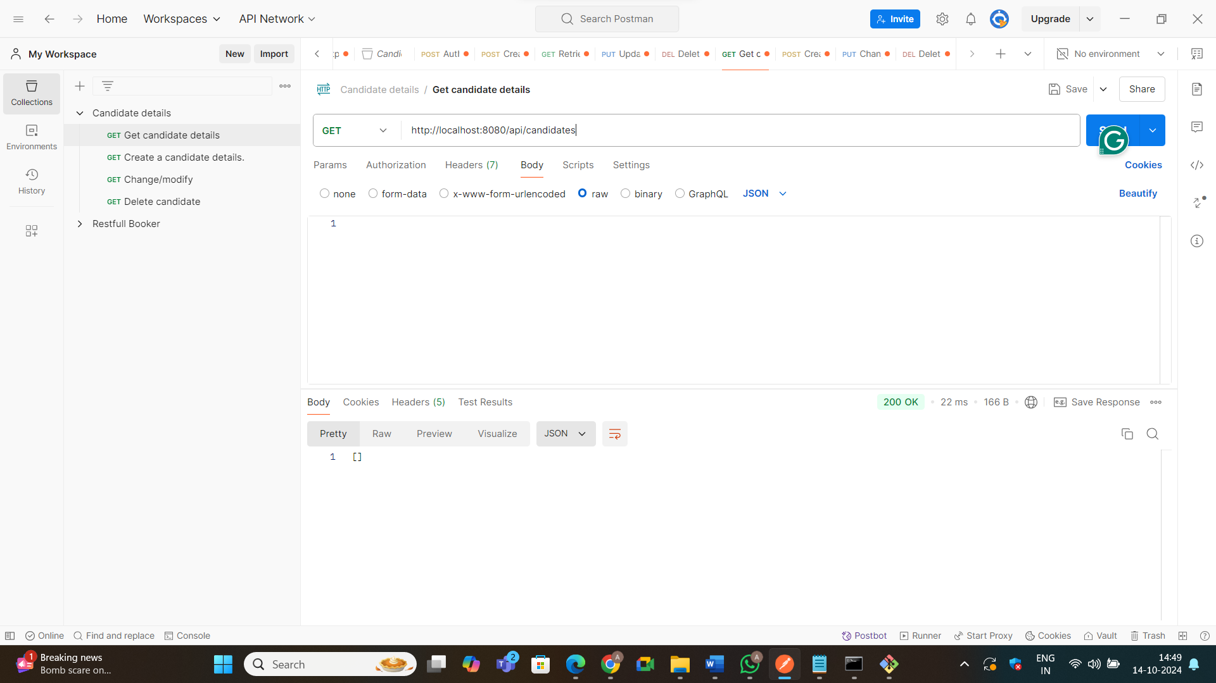

1. **POST**: Post is used to end data to the server to create a new resource.

Create a candidate details.

Method: POST URL: http://localhost:8080/api/candidates

**Select**

a. Body

b. Select raw

c. Select JSON.

{

"name": "Azim",

"batch": "API Testing"

}

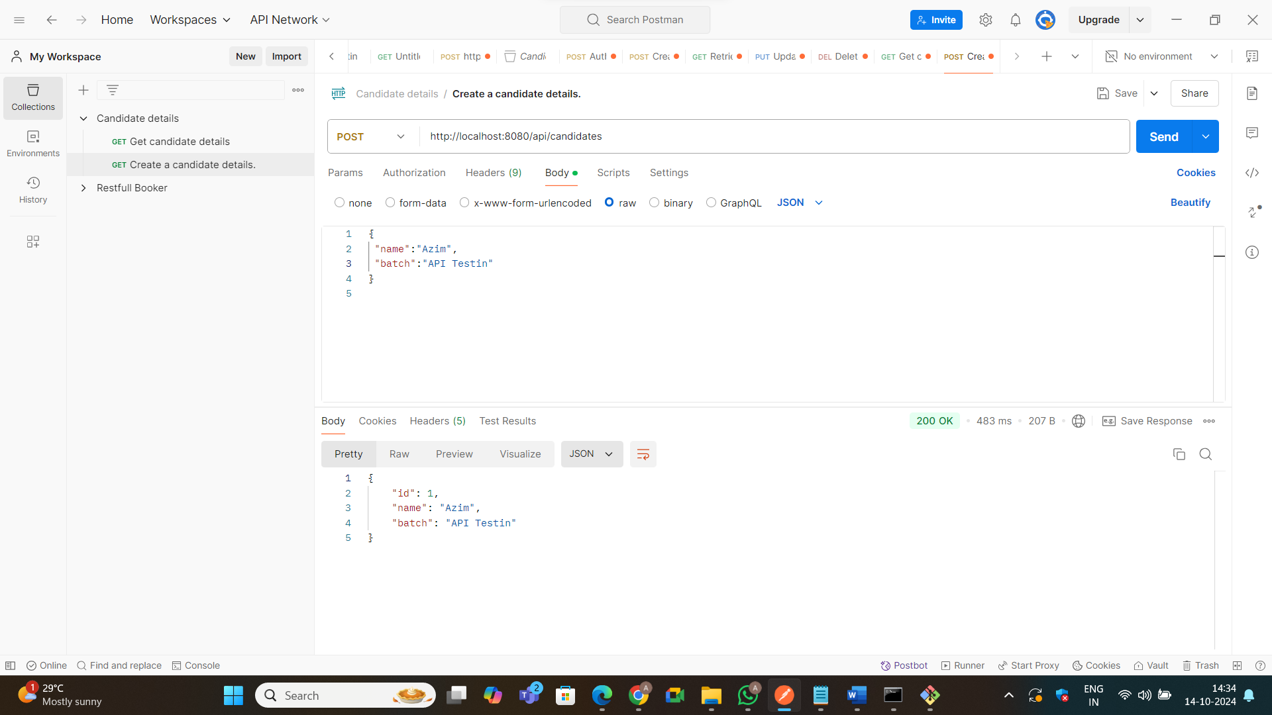

1. **PUT:**  Update an existing resource or create a resource at a specific URL.

Change/Modify

Method: PUT URL: http://localhost:8080/api/candidates/{id}

{

 "name": "changing name of one"

}

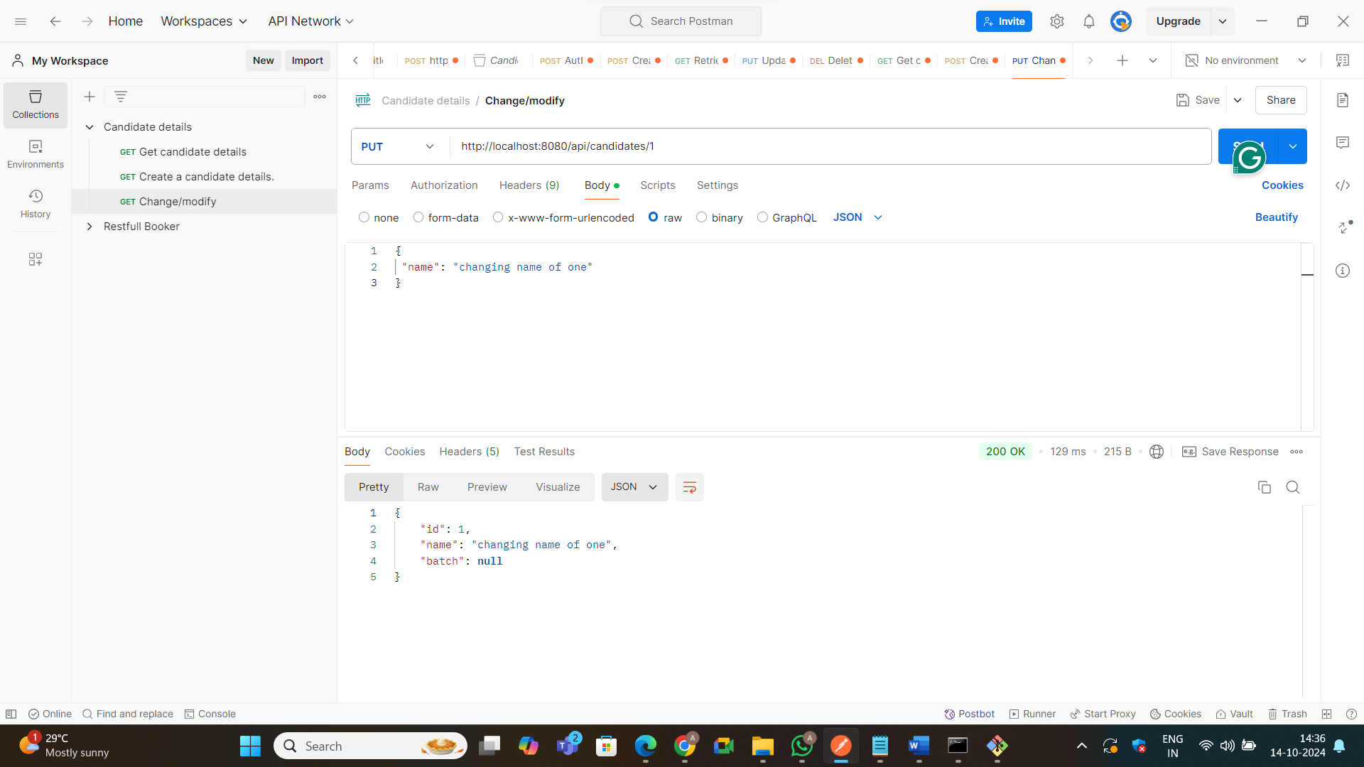

5. **DELETE**: Remove a resource from the server.

Delete candidate

Method: DELETE URL: [http://localhost:8080/api/candidates/{id}](http://localhost:8080/api/candidates/%7bid%7d)

